Week 10 Assignment

Part 1:

Challenge 1:1: Read the directions, clicked on the links.

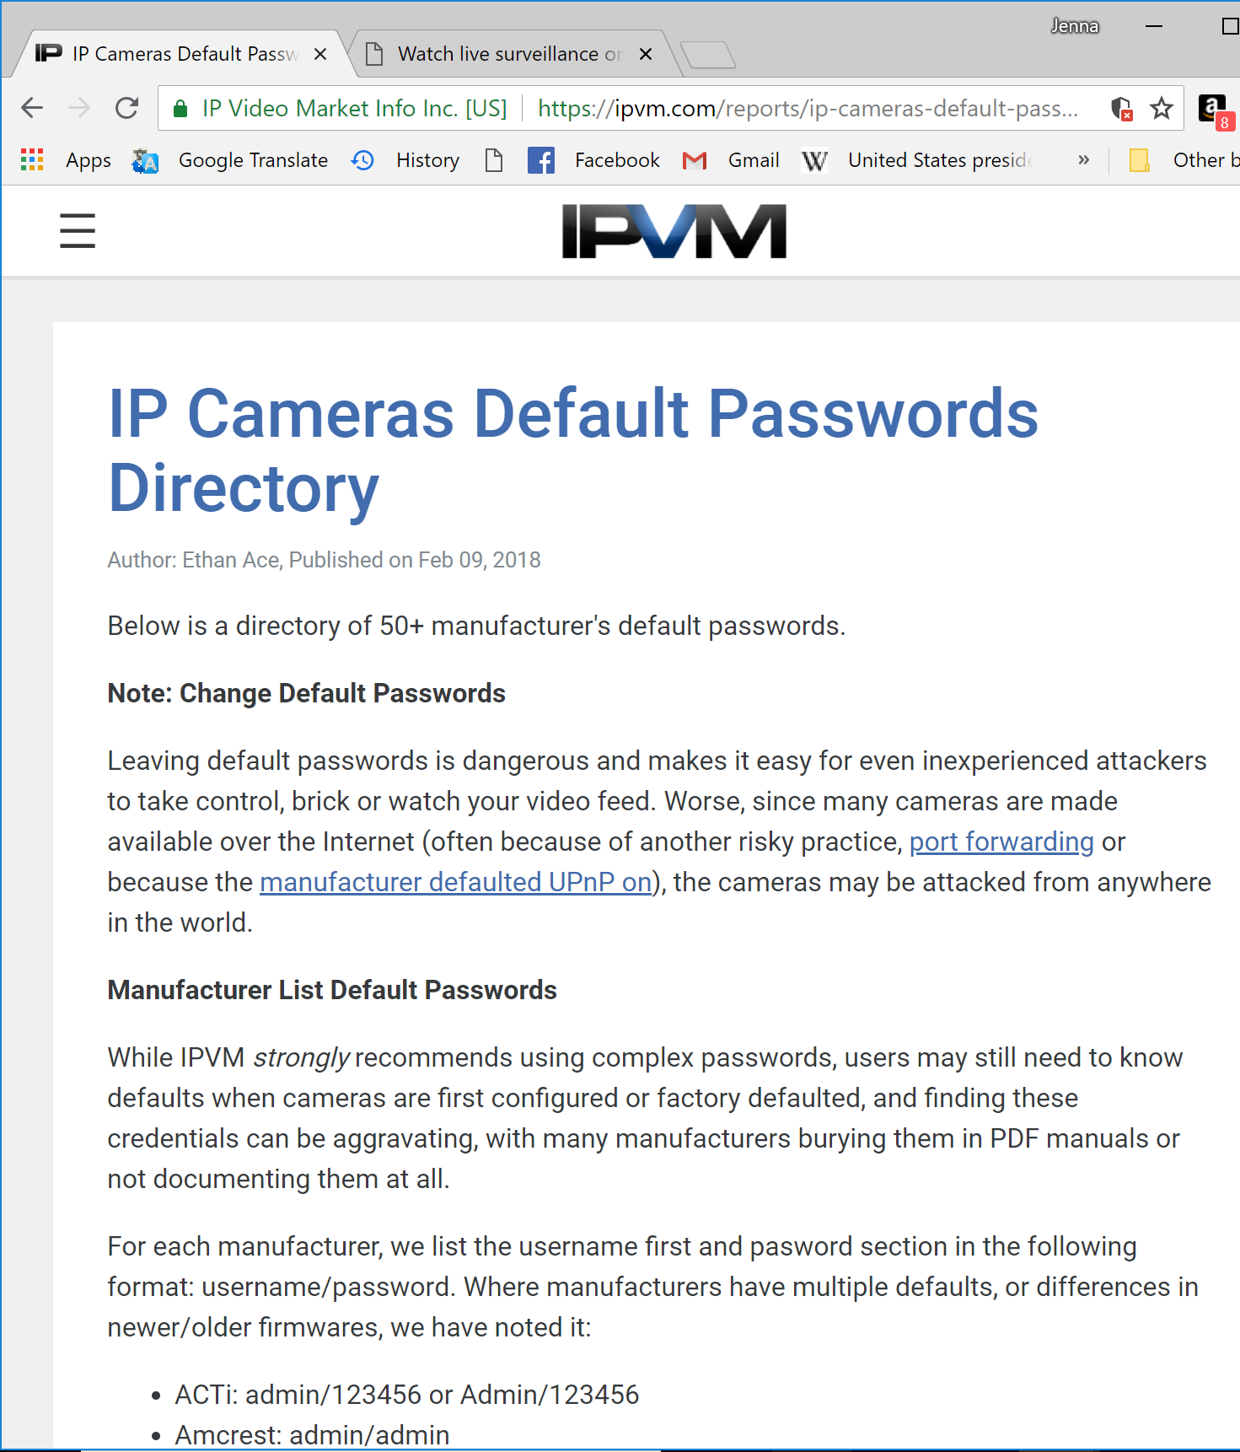

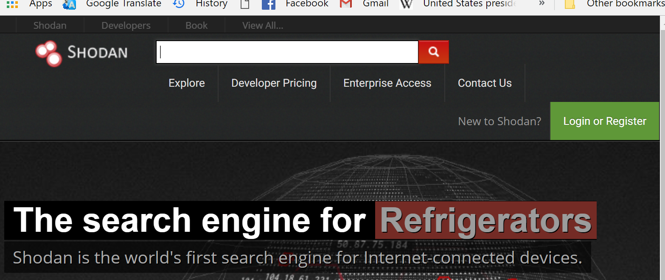

Milestone 2: I tried to filter through the Shodan website like it said in the directions. However, when I typed the different search phrases that Codepath provided I got error messages so I don’t know if I was entering the information in the correct space.

Part 2:

Challenge 2.0:

For this part of the assignment I tried to download tails from <https://tails.boum.org/install/vm-download/index.en.html>. It wouldn’t download as an ISO, the time remaining kept increasing.

So then I tried to download it as a torrent file. I couldn’t get that file to work when setting up the vm. Then I had another classmate email me their tails iso download and when I tried to download that it still said failed. I didn’t know what else to try. I wanted to complete the rest of the lab, but it is all in the tails vm so I was unable to.

